**BIG DATA ANALYTICS**

**COMP-SCI 5590BD**

**Summer Semester -2014**

**Game 2048 Using Sensor**



**Instructor: Group members:**

**Dr.Yugyung Lee L V Sandeep Bathina**

**TA: Jeevana Tunnuguntla**

**Feichen Shen Goutham Marikanti**

**Ramakrishna Reddy Beeravalli**

**TABLE OF CONTENTS**

|  |  |  |
| --- | --- | --- |
| **Sl.no** | **CONTENTS** | **Page No.** |
| 1 | Introduction of the Game | 2 |
| 2 | Project Goal and Objectives | 2 |
| 3 | First Increment | 3 |
| 4 | Second Increment | 8 |
| 5 | Third Increment | 14 |
| 6 | Fourth Increment | 22 |
| 7 | User Manual | 33 |
| 8 | Individual Contribution | 38 |
| 9 | Presentation Materials | 39 |
| 10 | Implementation Package | 40 |
| 11 | Scrum Do | 43 |
| 12 | Video File | 45 |
| 13 | Bibliography | 45 |

**Game 2048 Using Sensor**

**Game Introduction:**

A Large potential audience for android games and ease of play using sensor devices make android game development using sensor device a very attractive prospect. Number Games are always fun to play with. Not only they are entertaining but also helps in developing intellectual ability of the users.

2048 is a single player puzzle game which is highly popular among the android pool. The idea is to move or slide the tiles with numbers on a grid to sum them up and create a tile which makes up to 2048. 2048 is a "simple but hard to win" type game. It is possible to show all the four gestures i.e., top, down, left and right.

**Goals and Objective:**

To develop 2048game which is compatible on an android device and can be navigated using the sensor tag. To collect the data (i.e.) text file from an android device, this file mainly contains the number of gestures in a particular day in which a user is playing. Then we need to push this file to the Hadoop file system and we analyze this data to generate report and also we will provide recommendations to user to improvise them in their field of interest.

**Motivation:**

*2048* is played on a simple gray 4×4 grid, with numbered tiles that slide smoothly when a player moves them using the four arrow keys. Every turn, a new tile will randomly appear in an empty spot on the board with a value of either 2 or 4. Tiles slide as far as possible in the chosen direction until they are stopped by either another tile or the edge of the grid. If two tiles of the same number collide while moving, they will merge into a tile with the total value of the two tiles that collided. The resulting tile cannot merge with another tile again in the same move. Higher-scoring tiles emit a soft glow.

# First Increment

**Project goal and Objectives**

* **Motivation**: Gaming is the new face of entertainment. Upon learning that this form of entertainment also adds to the development of knowledge and intelligence of end user, we have chosen this work on this project. On an elaborated view, analysis of scores yielded from the game would be useful in assessing the intelligence level of individuals.
* **Significance**: Using generated data from game application we do analyze Data, based on analysis we can prepare a statistics of the user in his/her desired field. This type of analysis not only helps a particular user but also help many organizations, health organization and educational institution to asses a student or employee field of interest and to determine their capability.
* **Objectives:** our main goal in this project is to collect the data (i.e.) text file from an android device, this file mainly contains pattern in which a user is playing. Then we need to push this file to the hadoop file system and using an algorithm we analyze this data to generate report and also we will provide recommendations to user to improvise them in their field of interest.
* **System features:**

**OS:** windows/Linux

**Ram:** 4 GB or above

Android device version: at least 4.3

**IDE**: Eclipse ADT (to run android application), Eclipse kelper/juno (to run java application)

**Devices:** Sensor tags, android mobile having Bluetooth above 4.2.

**Activity Recognition scenario and data collection**

* **Devices/ Sensors**: CC2541 Sensor Tag  Development Kit, Computer with a minimum of i7 processor and 4gb Ram
* **Data Collection**: Data that would be generated from the game is in .txt file format and it is collected and stored in tables which we have created in HBASE.
* **Motion/activity Model**:

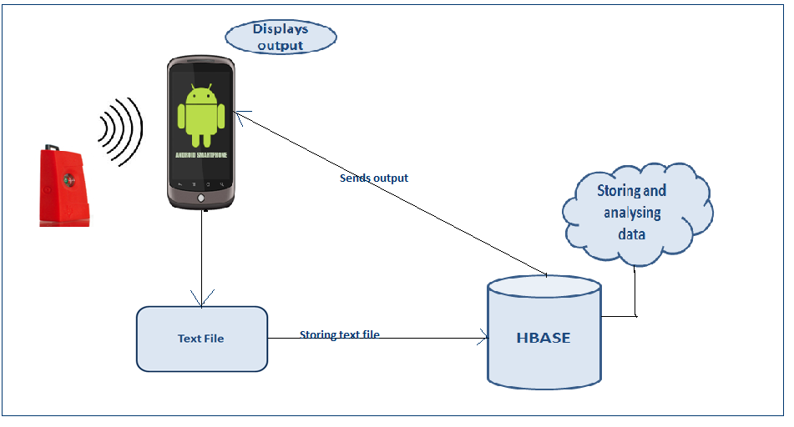

* **Analytical tasks**: The data shall be assessed for adaptive level information, and the performance of the gamer would be analysed based on the score he/she scores.
* **Design of mobile client :**

**Features**: android device version-4.4.2

**Styles and GUI:**

1. In order to develop the project, we got the open source android game from the internet. Here, we will make some changes in the game source code according to our project interest.

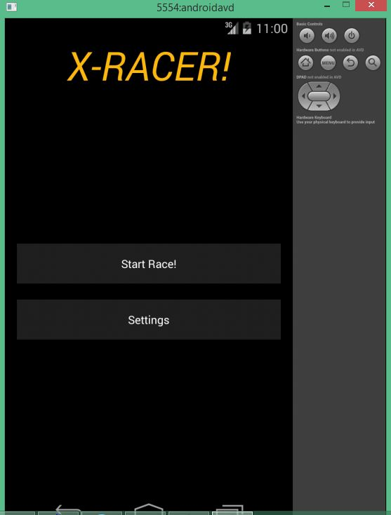

1. So here, we will capture the objects according to the questions we fire. So based on that we will retrieve the report and analyze them accordingly.

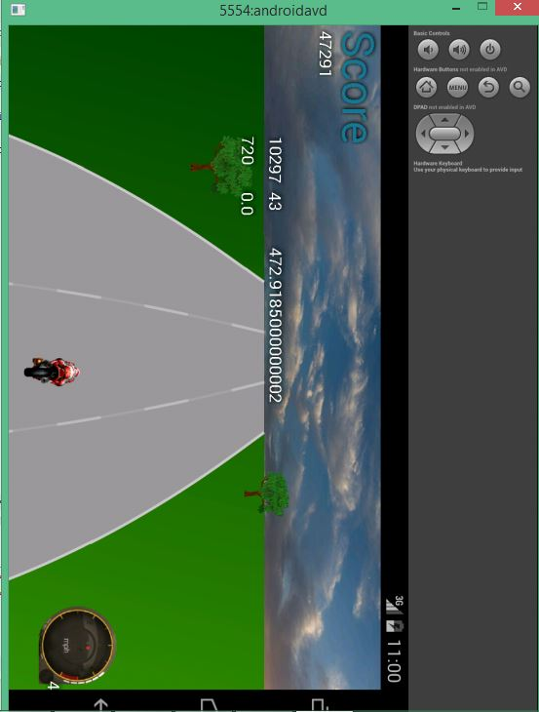

1. The analyzed part here is kept in the HBASE system tables in the form of rows and columns

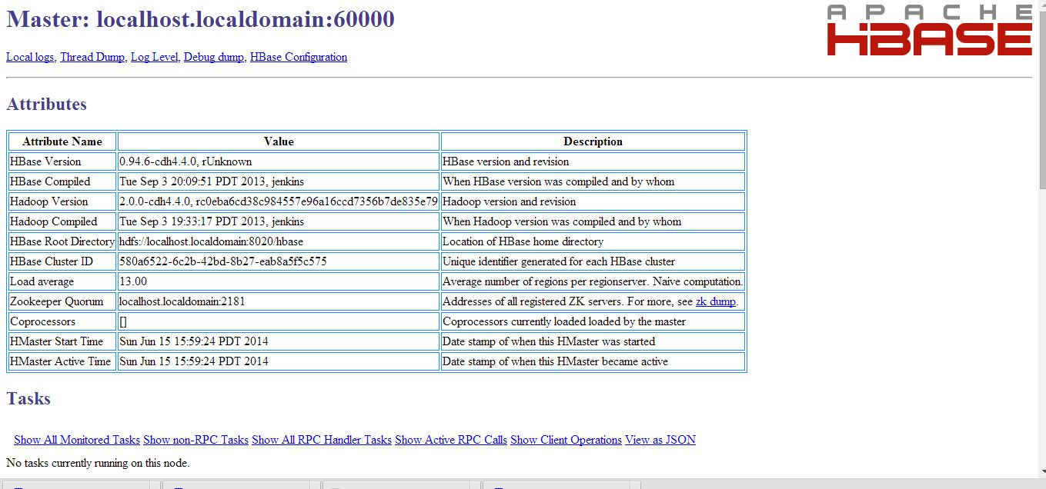

**Technologies**: Java, HBASE.

* **Project Planning with Scrumdo:**

https://www.scrumdo.com/organization/cs590bd/dashboard

* **Related work :**

<http://www.mel.nist.gov/msidlibrary/doc/serious_games02.pdf>

<http://newsroom.ucla.edu/releases/is-technology-producing-a-decline-79127>

[http://www.techradar.com/us/news/gaming/consoles/why-virtual-reality-gaming-is-the-future-of- playstation-4-1217071](http://www.techradar.com/us/news/gaming/consoles/why-virtual-reality-gaming-is-the-future-of-playstation-4-1217071)

<http://www.lcc.uma.es/~ccottap/papers/lara13review.pdf>

* **Bibliography**

<http://www.edureka.in/>

<http://developer.android.com/training/basics/actionbar/index.html>

<http://efytimes.com/e1/fullnews.asp?edid=134678>

# Second Increment

**Project goal and Objectives**

* **Motivation**: Gaming is the new face of entertainment. Upon learning that this form of entertainment also adds to the development of knowledge and intelligence of end user, we have chosen this work on this project. On an elaborated view, analysis of scores yielded from the game would be useful in assessing the intelligence level of individuals.
* **Significance**: Using generated data from game application we do analyze Data, based on analysis we can prepare a statistics of the user in his/her desired field. This type of analysis not only helps a particular user but also help many organizations, health organization and educational institution to asses a student or employee field of interest and to determine their capability.
* **Objectives:** our main goal in this project is to collect the data (i.e.) text file from an android device, this file mainly contains pattern in which a user is playing. Then we need to push this file to the hadoop file system and using an algorithm we analyze this data to generate report and also we will provide recommendations to user to improvise them in their field of interest.
* **System features:**

**OS:** windows/Linux

**Ram:** 4 GB or above

Android device version: at least 4.3

**IDE**: Eclipse ADT (to run android application), Eclipse kelper/juno (to run java application)

**Devices:** Sensor tags, android mobile having Bluetooth above 4.2.

**Activity Recognition scenario and data collection**

* **Devices/ Sensors**: CC2541 Sensor Tag  Development Kit, Computer with a minimum of i7 processor and 4gb Ram
* **Data Collection**: Data that would be generated from the game is in .txt file format and it is collected and stored in tables which we have created in HBASE.
* **Motion/activity Model**:



* **Analytical tasks**: The data shall be assessed for adaptive level information, and the performance of the gamer would be analysed based on the score he/she scores.
* **Design of mobile client :**

**Features**: android device version-4.4.2

**Styles and GUI:**

1. In order to develop the project, we got the open source android game from the internet. Here, we will make some changes in the game source code according to our project interest.



1. So here, we will capture the objects according to the questions we fire. So based on that we will retrieve the report and analyze them accordingly.

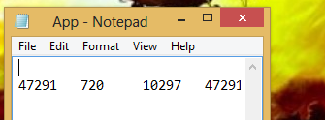

1. The analyzed part here is kept in the HBASE system tables in the form of rows and columns

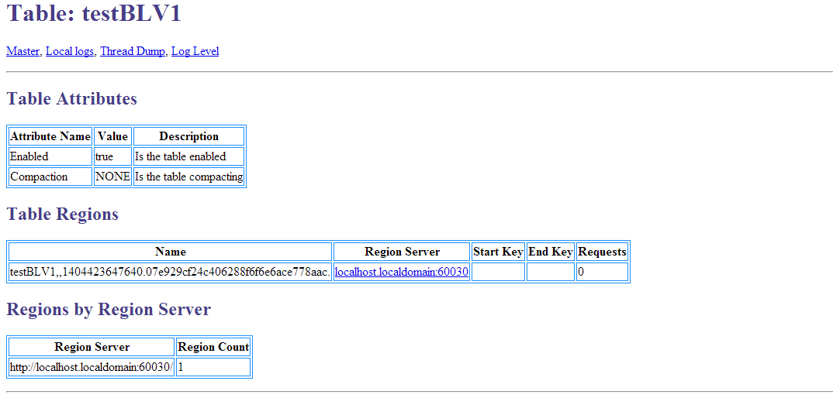

1. **Generate sequence files for the collected data from sensor**

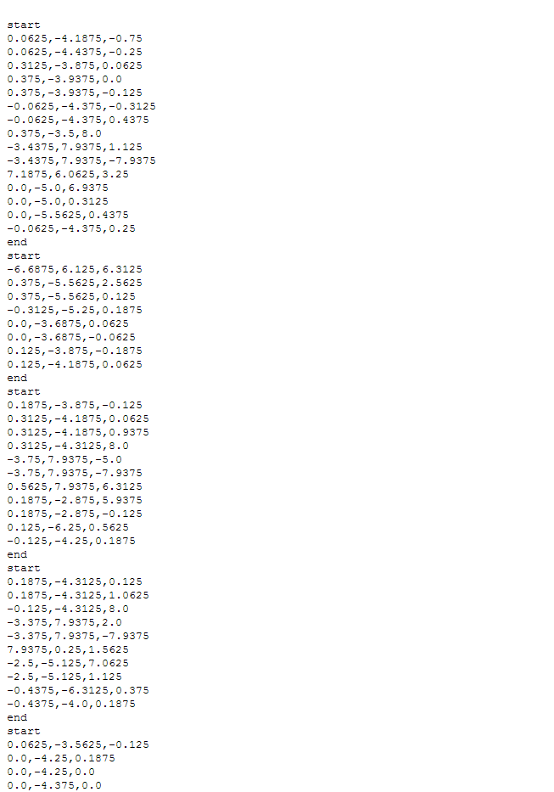

1. **Now test the gestures by using a test file having punch, left and right gestures**

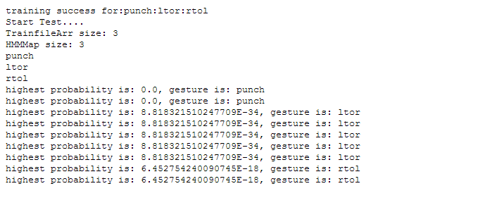

**Technologies**: Java, HBASE.

* **Project Planning with Scrumdo:**

https://www.scrumdo.com/organization/cs590bd/dashboard

* **Related work :**

<http://www.mel.nist.gov/msidlibrary/doc/serious_games02.pdf>

<http://newsroom.ucla.edu/releases/is-technology-producing-a-decline-79127>

[http://www.techradar.com/us/news/gaming/consoles/why-virtual-reality-gaming-is-the-future-of- playstation-4-1217071](http://www.techradar.com/us/news/gaming/consoles/why-virtual-reality-gaming-is-the-future-of-playstation-4-1217071)

<http://www.lcc.uma.es/~ccottap/papers/lara13review.pdf>

* **Bibliography**

<http://www.edureka.in/>

<http://developer.android.com/training/basics/actionbar/index.html>

<http://efytimes.com/e1/fullnews.asp?edid=134678>

# Third Increment

**Project goal and Objectives**

* **Motivation**: Gaming is the new face of entertainment. Upon learning that this form of entertainment also adds to the development of knowledge and intelligence of end user, we have chosen this work on this project. On an elaborated view, analysis of scores yielded from the game would be useful in assessing the intelligence level of individuals.
* **Significance**: Using generated data from game application we do analyze Data, based on analysis we can prepare a statistics of the user in his/her desired field. This type of analysis not only helps a particular user but also help many organizations, health organization and educational institution to asses a student or employee field of interest and to determine their capability.
* **Objectives:** our main goal in this project is to collect the data (i.e.) text file from an android device, this file mainly contains pattern in which a user is playing. Then we need to push this file to the hadoop file system and using an algorithm we analyze this data to generate report and also we will provide recommendations to user to improvise them in their field of interest.
* **System features:**

**OS:** windows/Linux

**Ram:** 4 GB or above

Android device version: at least 4.3

**IDE**: Eclipse ADT (to run android application), eclipse kelper/juno (to run java application)

**Devices:** Sensor tags, android mobile having Bluetooth above 4.2.

**Activity Recognition scenario and data collection**

* **Devices/ Sensors**: CC2541 Sensor Tag  Development Kit, Computer with a minimum of i7 processor and 4gb Ram
* **Data Collection**: Data that would be generated from the game is in .txt file format and it is collected and stored in tables which we have created in HBASE.
* **Motion/activity Model**:



* **Analytical tasks**: The data shall be assessed for adaptive level information, and the performance of the gamer would be analysed based on the score he/she scores.
* **Design of mobile client :**

**Features**: android device version-4.4.2

**Styles and GUI:**

**Game Description**

**2048Game**

It is a single player puzzle game, which requires the user to slide the number titles on a square 4*4 grid, and upon combining them a tile would be created which has a number 2048.

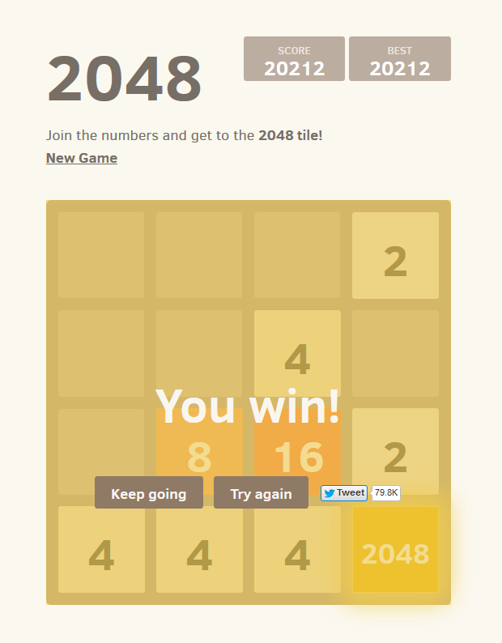

1. In order to develop the project, we got the open source for the 2048 game from the internet. Here, we will make some changes in the game source code according to our project interest.

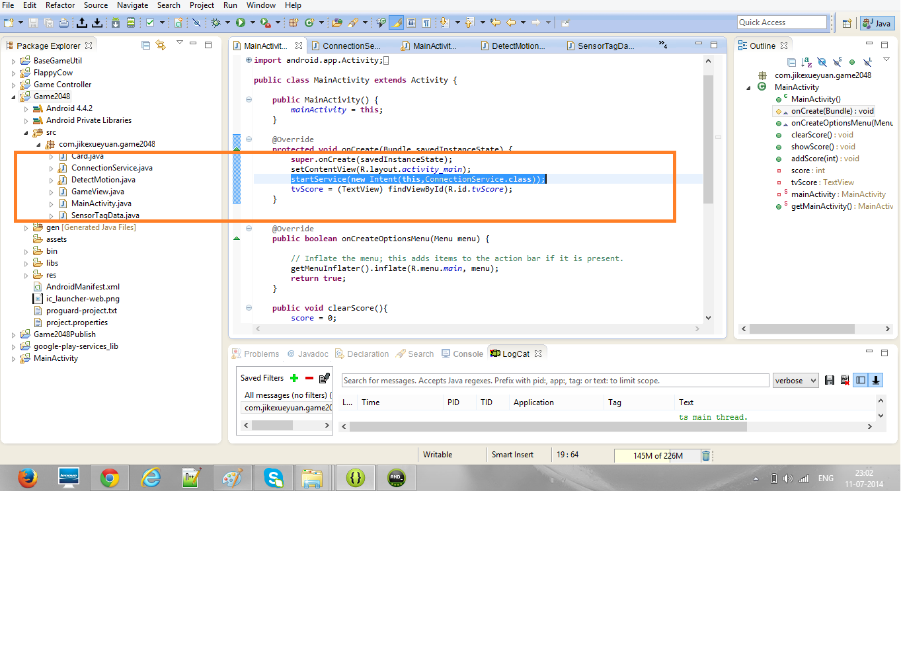 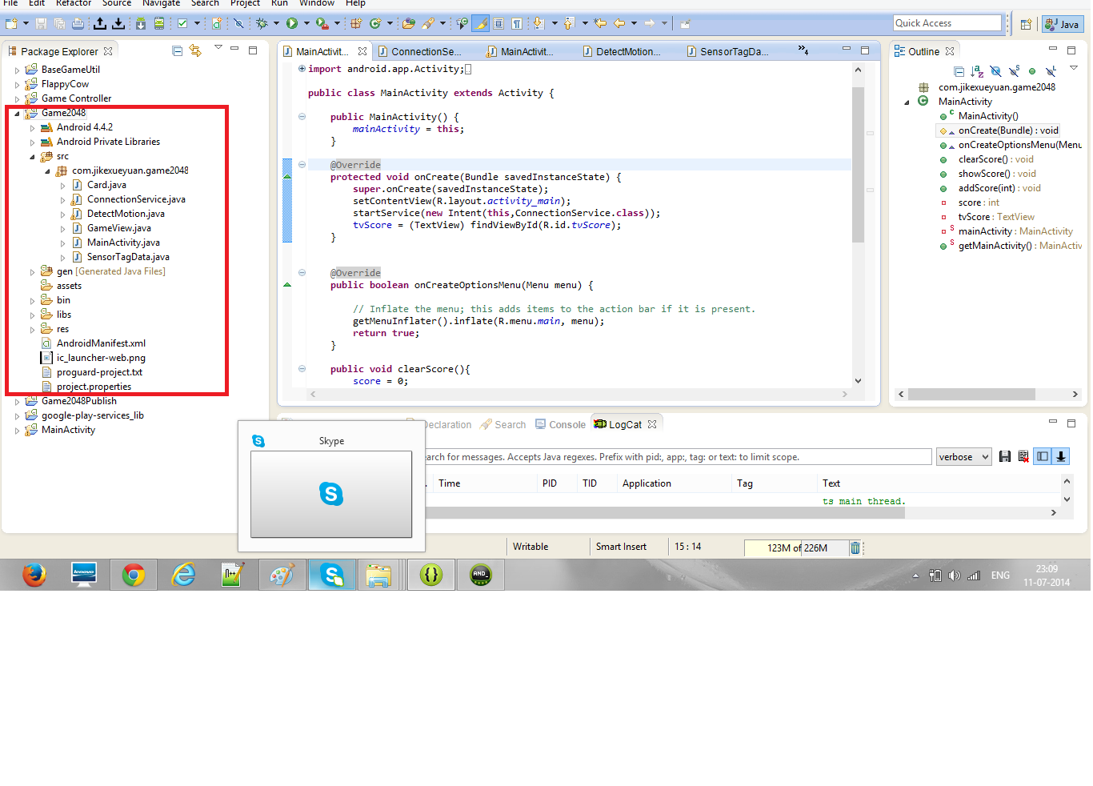

Gam

GAME

GTame

1. So here upon sliding the number tiles, there would a tile which shows up the sum of values being slide. The Game demonstration shows that when the sensor is moved towards right the tile values slides towards right and when slide towards left, the values sums up towards left and same in case of up and down. So based on that we will retrieve the report and analyze them accordingly.

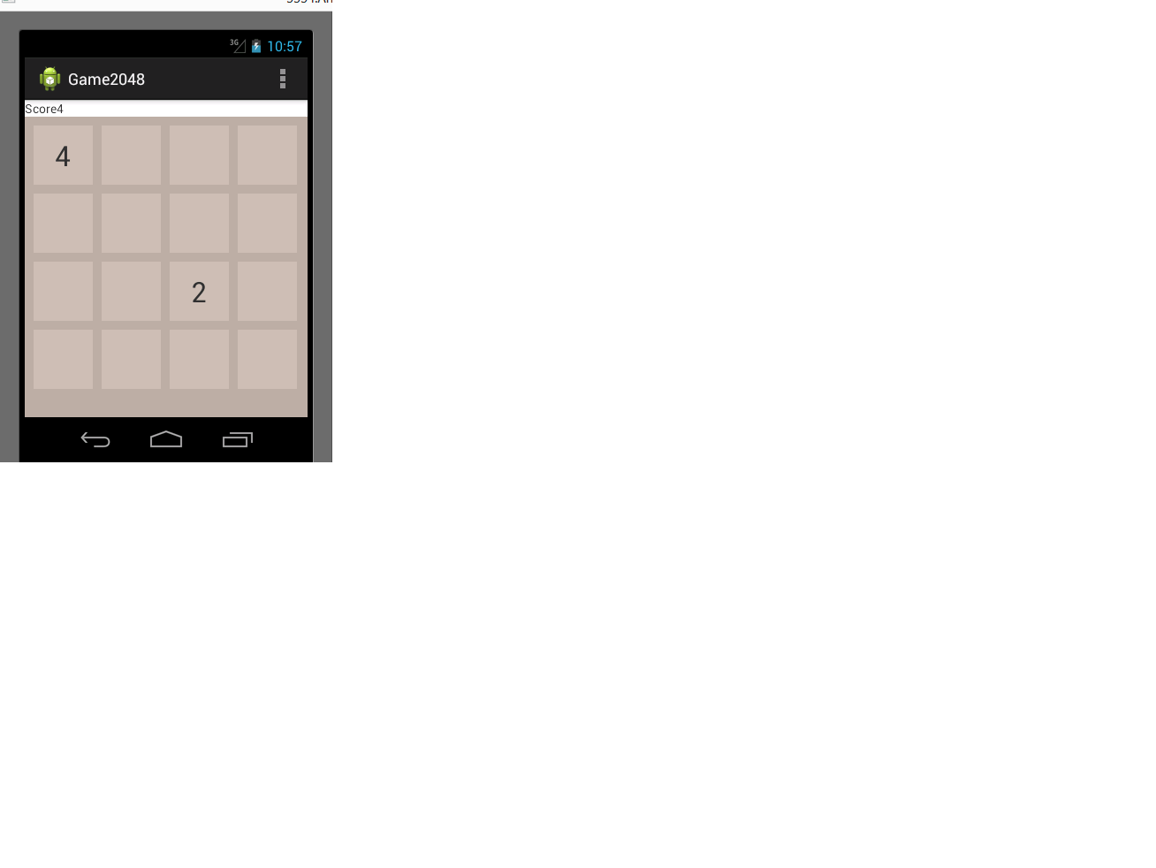

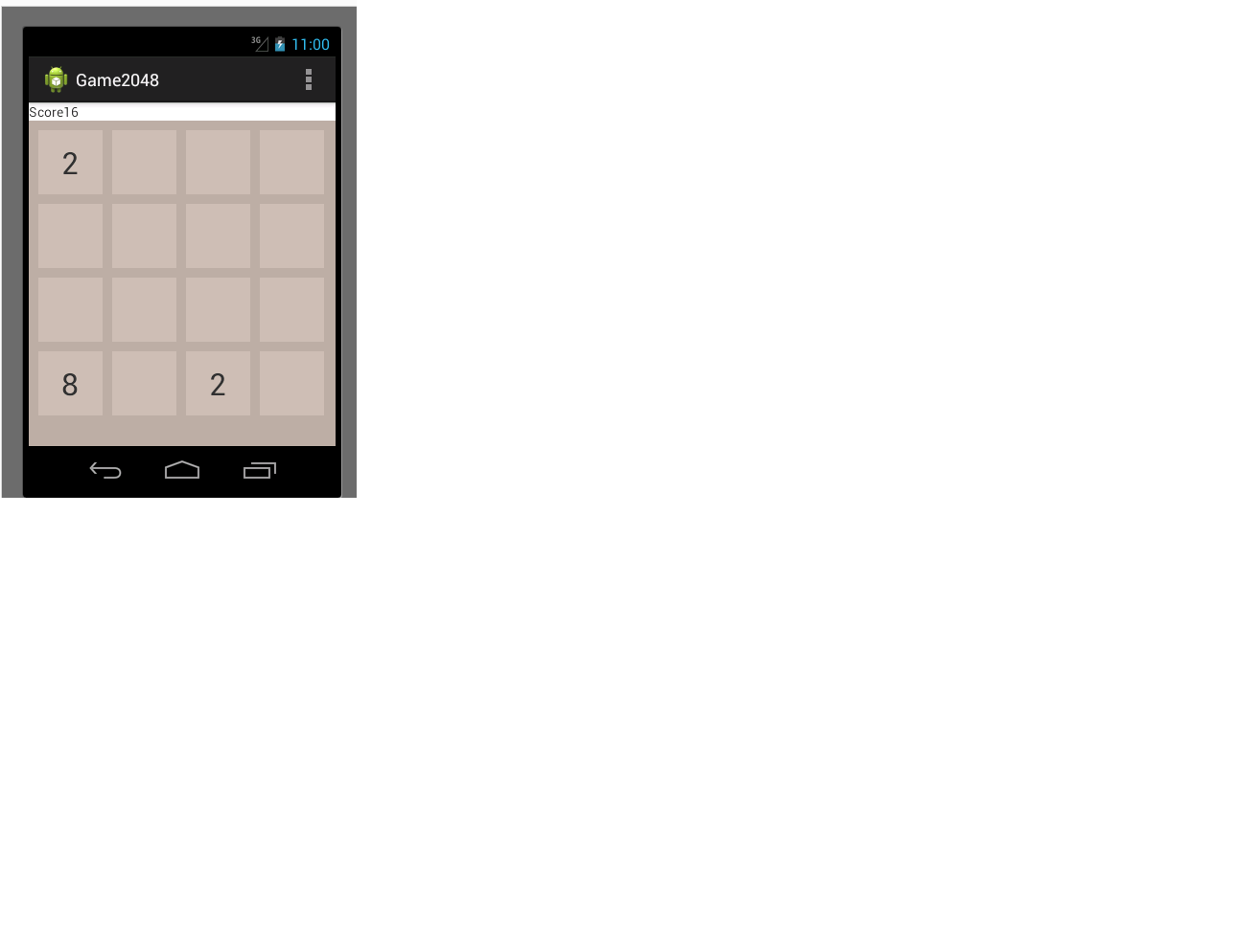

1. The analyzed part here is kept in the HBASE system tables in the form of rows and columns

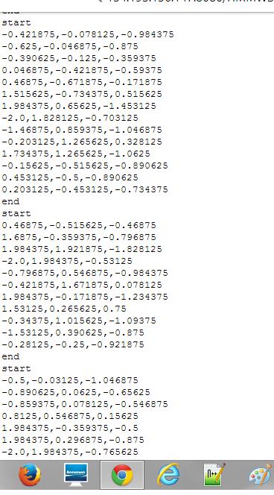

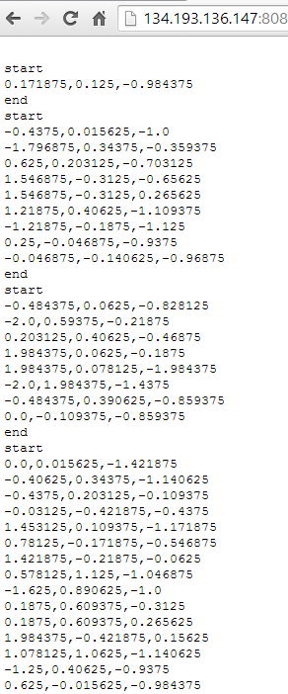

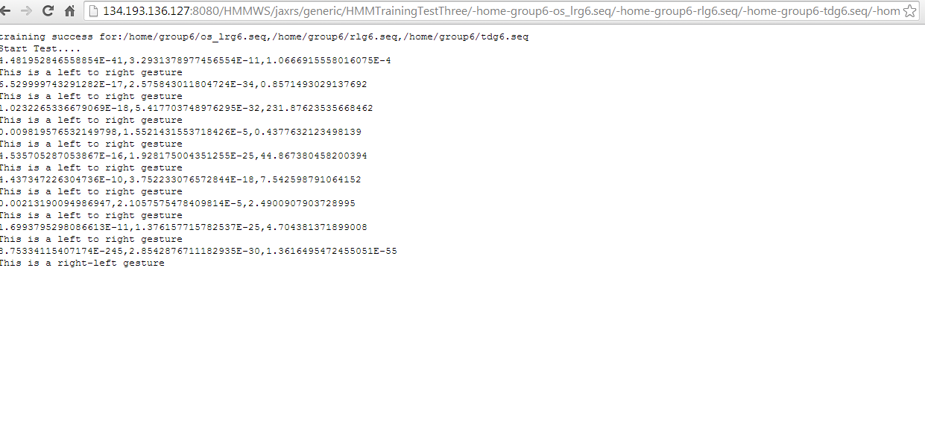

**Technologies**: JAVA, HBASE,

**Algorithms:**

**Data Filtering (Specify your approach/algorithm):**

In the filtering part, the data collected from the game is filtered by specifying start and end positions for the gesture. The similar way is followed for remaining gesture actions. The data collected is extracted based on K-means clustering Algorithm.

**Evaluation model (Specify your approach/algorithms in details):**

The machine learning algorithm we are going to use is by HMM Model. Here the probabilities are calculated and based on that the correct gesture is determined.

* **Project Planning with Scrumdo:**

[https://www.scrumdo.com/organization/cs590bd/dashboard](%20%20%20%20%20%20%20%20%20%20%20https://www.scrumdo.com/organization/cs590bd/dashboard)

* **Related work :**

<http://www.mel.nist.gov/msidlibrary/doc/serious_games02.pdf>

<http://newsroom.ucla.edu/releases/is-technology-producing-a-decline-79127>

<https://github.com/gabrielecirulli/2048>

<https://github.com/lanus1401/2048/tree/master/game2048/src/com/lanus/game2048>

<http://www.lcc.uma.es/~ccottap/papers/lara13review.pdf>

* **Bibliography**

<http://www.edureka.in/>

<http://developer.android.com/training/basics/actionbar/index.html>

<http://efytimes.com/e1/fullnews.asp?edid=134678>

# Fourth InCREMENT

**Project goal and Objectives**

* **Motivation**: Gaming is the new face of entertainment. Upon learning that this form of entertainment also adds to the development of knowledge and intelligence of end user, we have chosen this work on this project. On an elaborated view, analysis of scores yielded from the game would be useful in assessing the intelligence level of individuals.
* **Significance**: Using generated data from game application we do analyze Data, based on analysis we can prepare a statistics of the user in his/her desired field. This type of analysis not only helps a particular user but also help many organizations, health organization and educational institution to asses a student or employee field of interest and to determine their capability.
* **Objectives:** our main goal in this project is to collect the data (i.e.) text file from an android device, this file mainly contains pattern in which a user is playing. Then we need to push this file to the hadoop file system and using an algorithm we analyze this data to generate report and also we will provide recommendations to user to improvise them in their field of interest.
* **System features:**

**OS:** windows/linux

**Ram:** 4 GB or above

Android device version: at least 4.3

**IDE**: Eclipse ADT (to run android application), eclipse kelper/juno(to run java application)

**Devices:** Sensor tags, android mobile having Bluetooth above 4.2.

**Activity Recognition scenario and data collection**

* **Devices/ Sensors**: CC2541 Sensor Tag  Development Kit, Computer with a minimum of i7 processor and 4gb Ram
* **Data Collection**: Data that would be generated from the game is in .txt file format and it is collected and stored in tables which we have created in HBASE.
* **Motion/activity Model**:



* **Analytical tasks**: The data shall be assessed for adaptive level information, and the performance of the gamer would be analysed based on the score he/she scores.
* **Design of mobile client :**

**Features**: android device version-4.4.2

**Styles and GUI:**

**Game Description**

**2048Game**

It is a single player puzzle game, which requires the user to slide the number titles on a square 4*4 grid, and upon combining them a tile would be created which has a number 2048.



1. In order to develop the project, we got the open source for the 2048 game from the internet. Here, we will make some changes in the game source code according to our project interest.

 

Gam

GAME

GTame

1. So here upon sliding the number tiles, there would a tile which shows up the sum of values being slide. The Game demonstration shows that when the sensor is moved towards right the tile values slides towards right and when slide towards left, the values sums up towards left and same in case of up and down. So based on that we will retrieve the report and analyze them accordingly.





1. The analyzed part here is kept in the HBASE system tables in the form of rows and columns







**Technologies**: JAVA, HBASE,

**Algorithms:**

**Data Filtering (Specify your approach/algorithm):**

In the filtering part, the data collected from the game is filtered by specifying start and end positions for the gesture. The similar way is followed for remaining gesture actions. The data collected is extracted based on K-means clustering Algorithm.

**Evaluation model (Specify your approach/algorithms in details):**

The machine learning algorithm we are going to use is by HMM Model. Here the probabilities are calculated and based on that the correct gesture is determined.

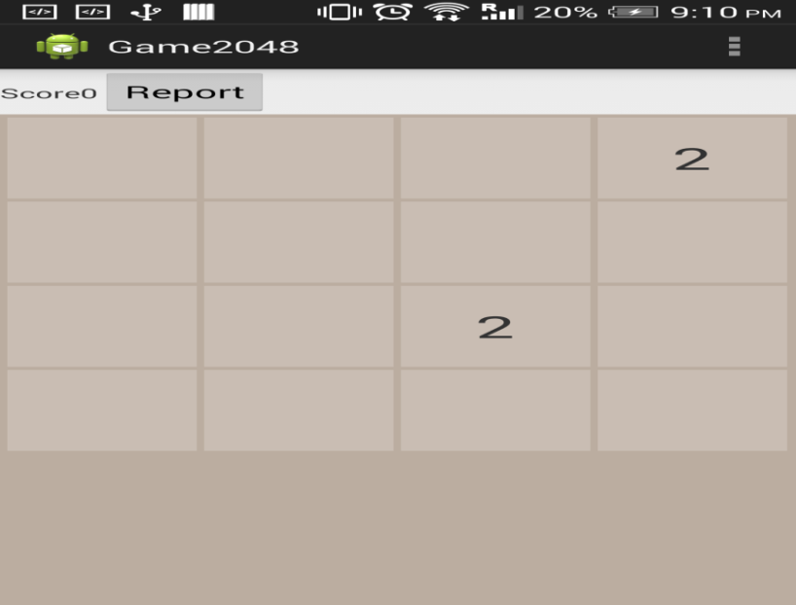

On clicking the above ‘Report’ button, the following screen will get displayed.

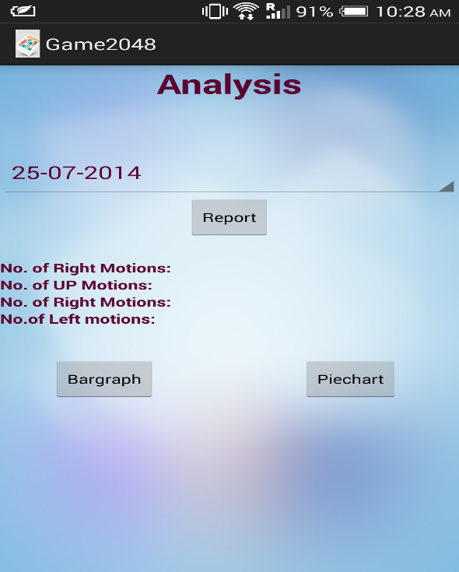

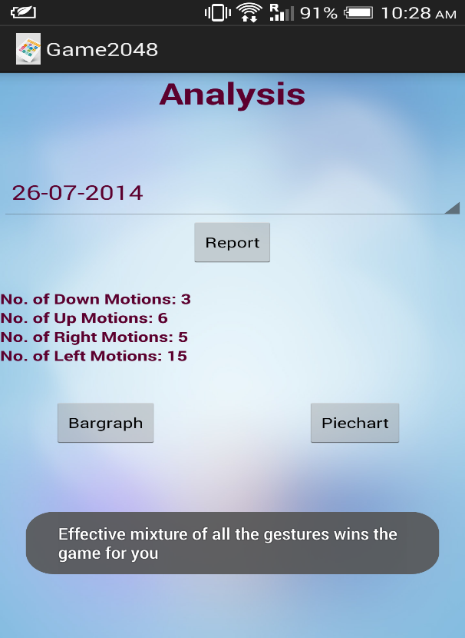

* **Graphical Report (Bar Graph, Pie Chart) :**

When the user selects a particular date and clicks on “Bar Graph button”, the corresponding day’s graph will be displayed with X-axis plotting the dates and Y- axis plotting number of motions corresponding to the gestures the user performs using the sensor tag.

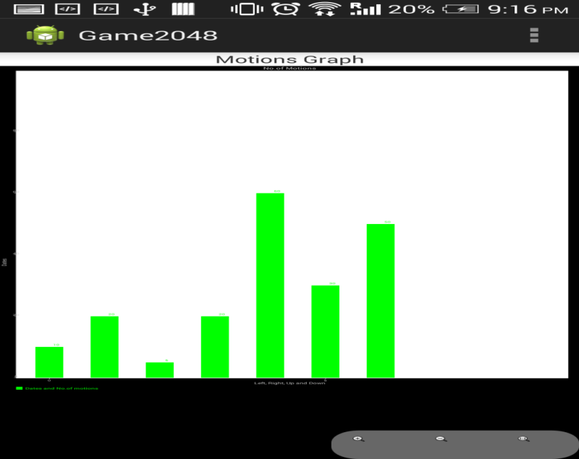

Similarly when the user selects a particular date in a particular time zone and clicks on the ‘Pie Chart’ button, a pie chart displaying the percentages of each of the four gestures as below:

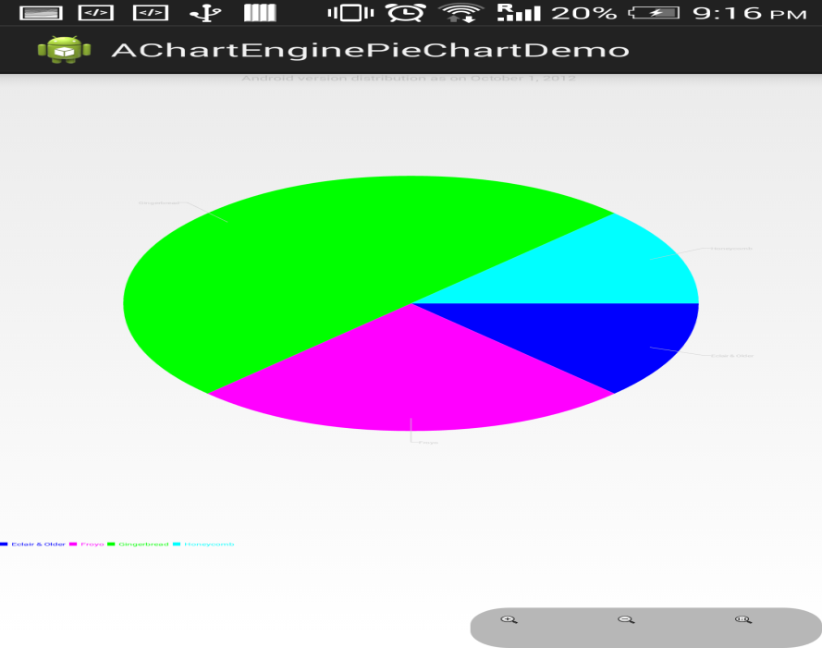

**Number of Users:**

Any number of users can play this game.

**Types of Motions/Activities:**

**Motions :->** Left, Right, Up, Down, Punch

Number of gestures: 5

**Data Preparation**



**Accuracy:**

**50-60%**

**Limitations**

* Capturing correct gesture became a challenging task.
* We took much care to obtain correct gesture because we need to hold sensor tag in only one direction while training.
* We have trained our application for 5 gestures.
* For each gesture we have generated 10-15 vector sets to train our application, it became a risky task to generate those many gestures for a single gesture. We took nearly 10-15 attempts to generate correct gesture.
* But we could reach 50-60% accuracy.

**Project Video**

**https://www.youtube.com/watch?v=uOh7_guqZis**

* **Project Planning with Scrumdo:**

[https://www.scrumdo.com/organization/cs590bd/dashboard](%20%20%20%20%20%20%20%20%20%20%20https://www.scrumdo.com/organization/cs590bd/dashboard)

* **Related work :**

<http://www.mel.nist.gov/msidlibrary/doc/serious_games02.pdf>

<http://newsroom.ucla.edu/releases/is-technology-producing-a-decline-79127>

<https://github.com/gabrielecirulli/2048>

<https://github.com/lanus1401/2048/tree/master/game2048/src/com/lanus/game2048>

<http://www.lcc.uma.es/~ccottap/papers/lara13review.pdf>

* **Bibliography**

<http://www.edureka.in/>

<http://developer.android.com/training/basics/actionbar/index.html>

<http://efytimes.com/e1/fullnews.asp?edid=134678>

**USER MANUAL**

1. Our application is game based(android game)

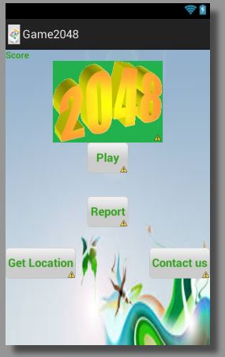

1. User needs to swipe left/right/top/bottom in order to play this game



1. We are converting touch based game to sensor based game, here we are using sensor tag

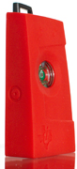 **Sensor tag**

As per our game , moving sensor tag in:

-left direction : left gesture

-right direction : right gesture

-up direction : up gesture

-punch : down gesture

4) By appliying these gestures effectively user can play the game.

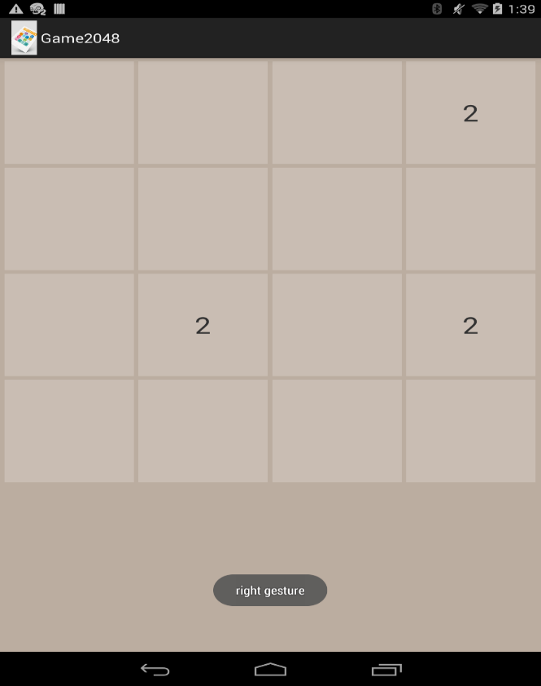

5) we are also giving user to provide make analysis , how he is palying

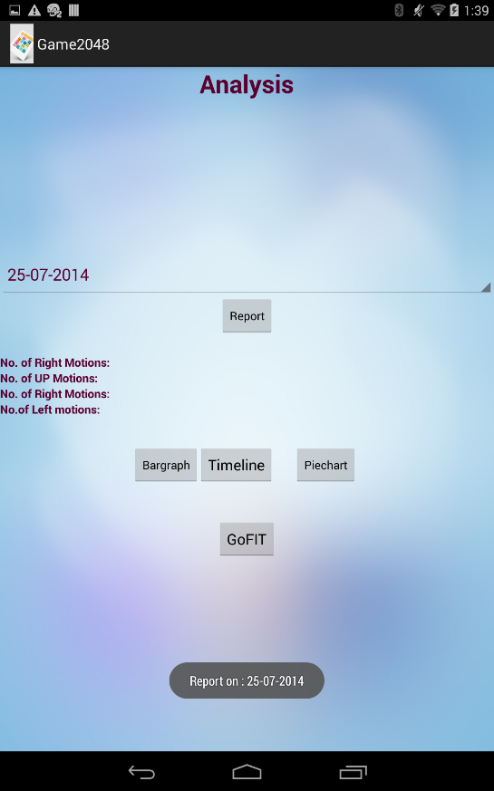

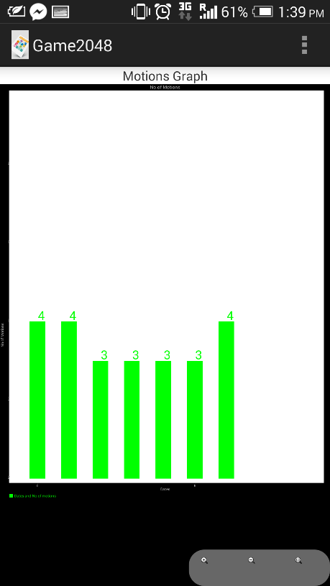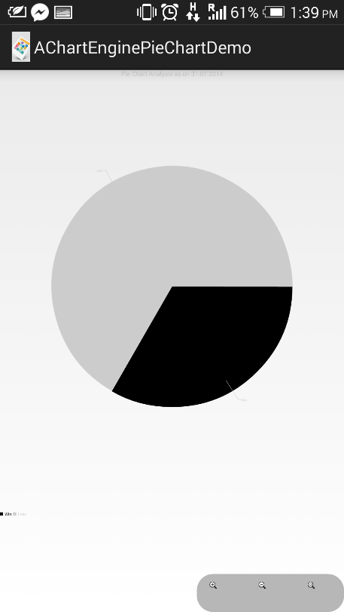

6) Based on user performace , they can check their health percentage by providing recommendation to user, how much more calories he need to burn inorder to be fit.

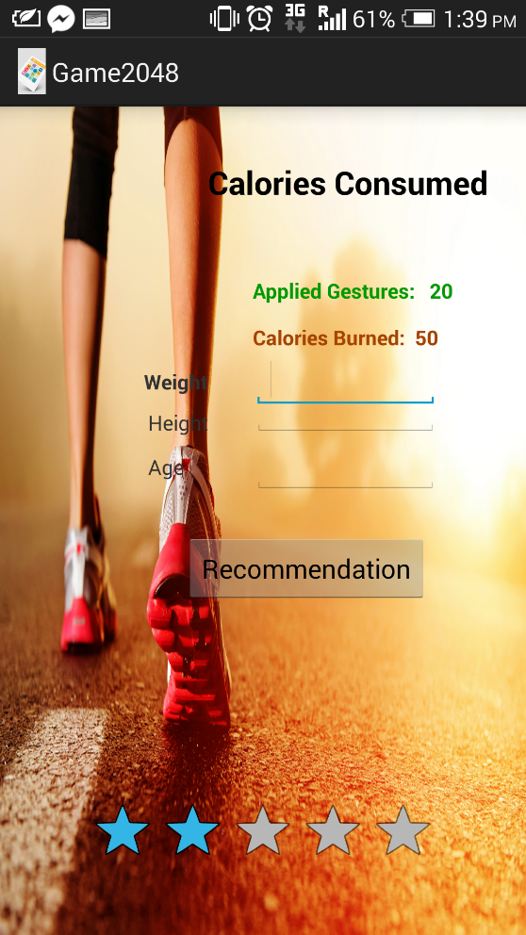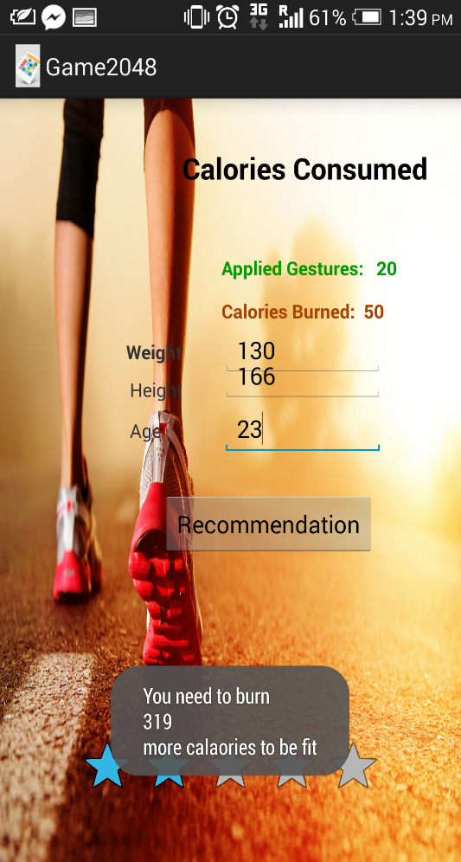

8) If any problems related to game or any suggestion , user can contact us using our helpline



9) User can also track his current location from where he is playing the game.

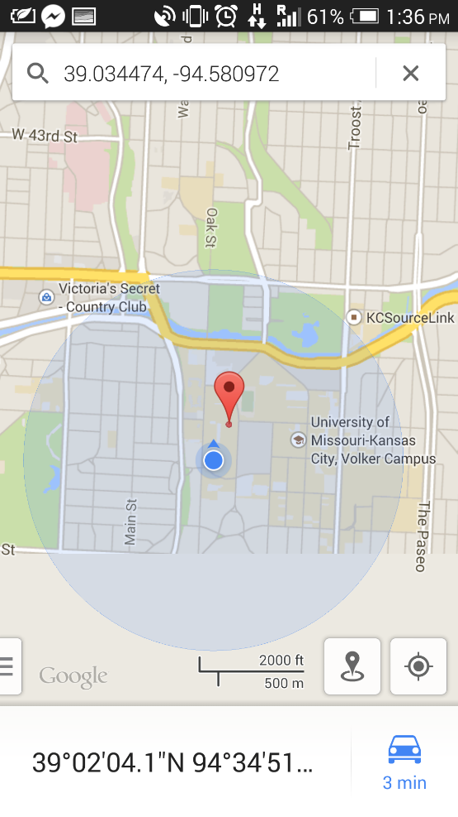

**Individual contribution**

We have divided our project into 4 phases:

**Planning & requirement phase**: Gathering information related to our project, searched open source code for our game application.

Contributors: Goutham and Ram Krishna

**Design phase**: Designing UI, designing home page UI, report page, fitpro Ingenerating pie chart, bargraph, timeline

Contributors: Jeevana, Blv Sandeep, Goutham

**Construction phase**: Wrote code for connection service thereby converting touch based game to sensor based game and making analysis report dynamically how many gestured used in a day. Added special features to track current location, contact customer service dynamically. Created a fitness testing page to know how much more calories need to be burn in order to be fit.

Contributors: Blv Sandeep, Jeevana, Ramkrishna

**Offline Phase**: Report work, preparing documentation, presentation part.

Contributors: Rama Krishna, Goutham

**Presentation Materials**

**Prezi Link:**

http://prezi.com/ltmrldbt4wyr/cs5590bd-project/

**Implementation Package**

**Report.java:**

public void addItemsOnSpinner2() {

spinner2 = (Spinner) findViewById(R.id.spinner2);

List<String> list = new ArrayList<String>();

list.add("25-07-2014");

list.add("26-07-2014");

list.add("27-07-2014");

//ArrayAdapter<String> dataAdapter = new ArrayAdapter<String>(this,

//android.R.layout.simple_spinner_item, list);

ArrayAdapter<String> dataAdapter = new ArrayAdapter<String>(this, R.layout.spinner_item,list);

dataAdapter.setDropDownViewResource(android.R.layout.simple_spinner_dropdown_item);

//dataAdapter.setDropDownViewResource(android.R.layout.spinner_item);

spinner2.setAdapter(dataAdapter);

}

**ConnectionService.java:**

try {

File returnType=whichGesture(dataPoints);

//Log.i("data", returnType.getAbsolutePath());

if(dataPoints.size()>6){

if(t.test(returnType)=="left"){

// Log.i("Stomp","stomp");

sendPatternTrigger("left");

}

else if(t.test(returnType)=="right"){

// Log.i("Stomp","stomp");

sendPatternTrigger("right");

}

else if (t.test(returnType)=="up"){

// Log.i("Stomp","stomp");

sendPatternTrigger("up");

}

else if (t.test(returnType)=="down"){

// Log.i("Stomp","stomp");

sendPatternTrigger("down");

}

}

} catch (Exception e) {

Log.i("error", "test failing");

}

dataPoints.clear();

}

**BarGraph.java:**

String line;

String[] values = new String[1000];

while ((line = bufferr.readLine()) != null && i<=6) {

//System.out.println(line);

values[i] = line;

String[] splits = values[i].split("\t");

day=Report.getDefaults("day", context);

System.out.println(splits[0]);

if(splits[0].equalsIgnoreCase(day))

{

String[] values1 = new String[2];

values1[0] = Integer.toString(i);

values1[1] = splits[5];

Thread.sleep(1000);

publishProgress(values1);

i++;

}

}

}catch(Exception e){ }

return null;

}

**ScrumDo**

**Scrum Do:**

**www.scrumdo.com/projects/project/project71/summary**

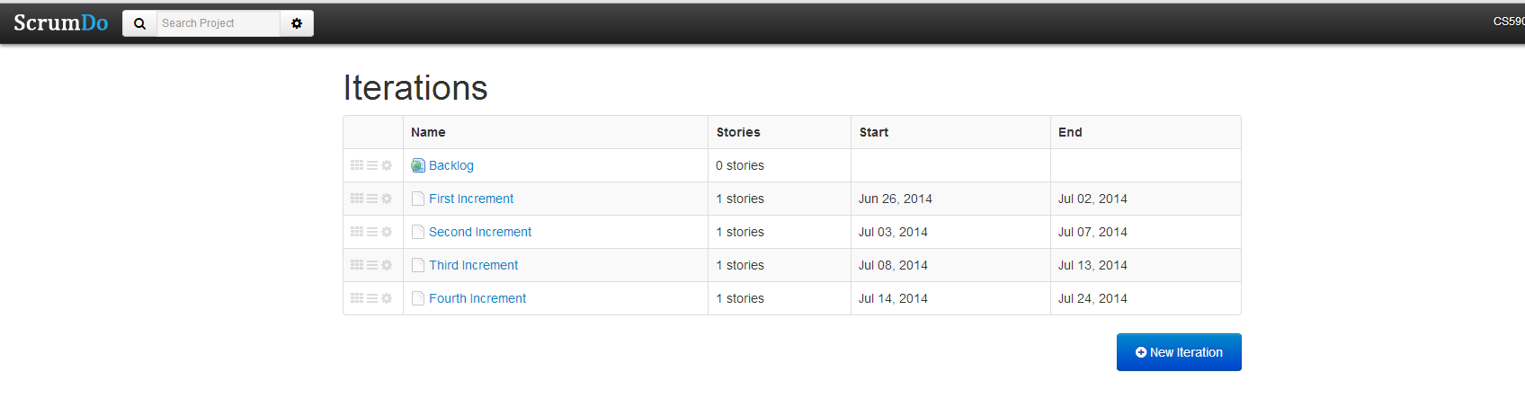

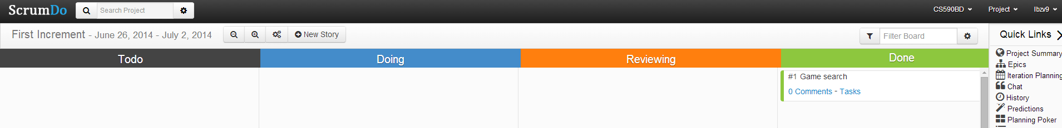

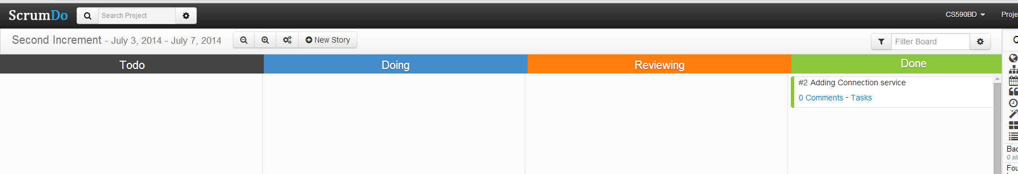

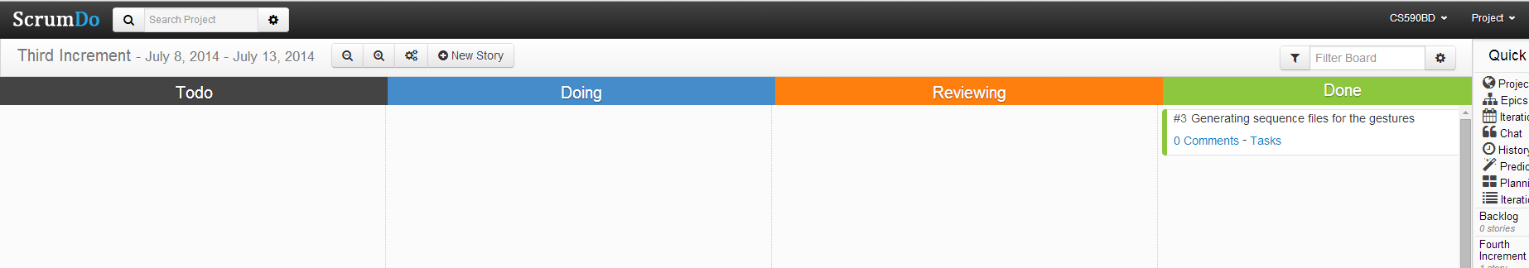

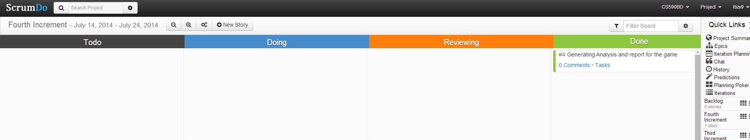

**Video File**

**YouTube Link:**

**https://www.youtube.com/watch?v=uOh7_guqZis**

**Bibliography**

<http://www.edureka.in/>

<http://developer.android.com/training/basics/actionbar/index.html>

<http://efytimes.com/e1/fullnews.asp?edid=134678>